DIGITAL LOGIC DESIGN PRACTICAL
AIM
To implement NOT, AND and OR gates using NAND gate using the NAND2TETRIS Simulator.
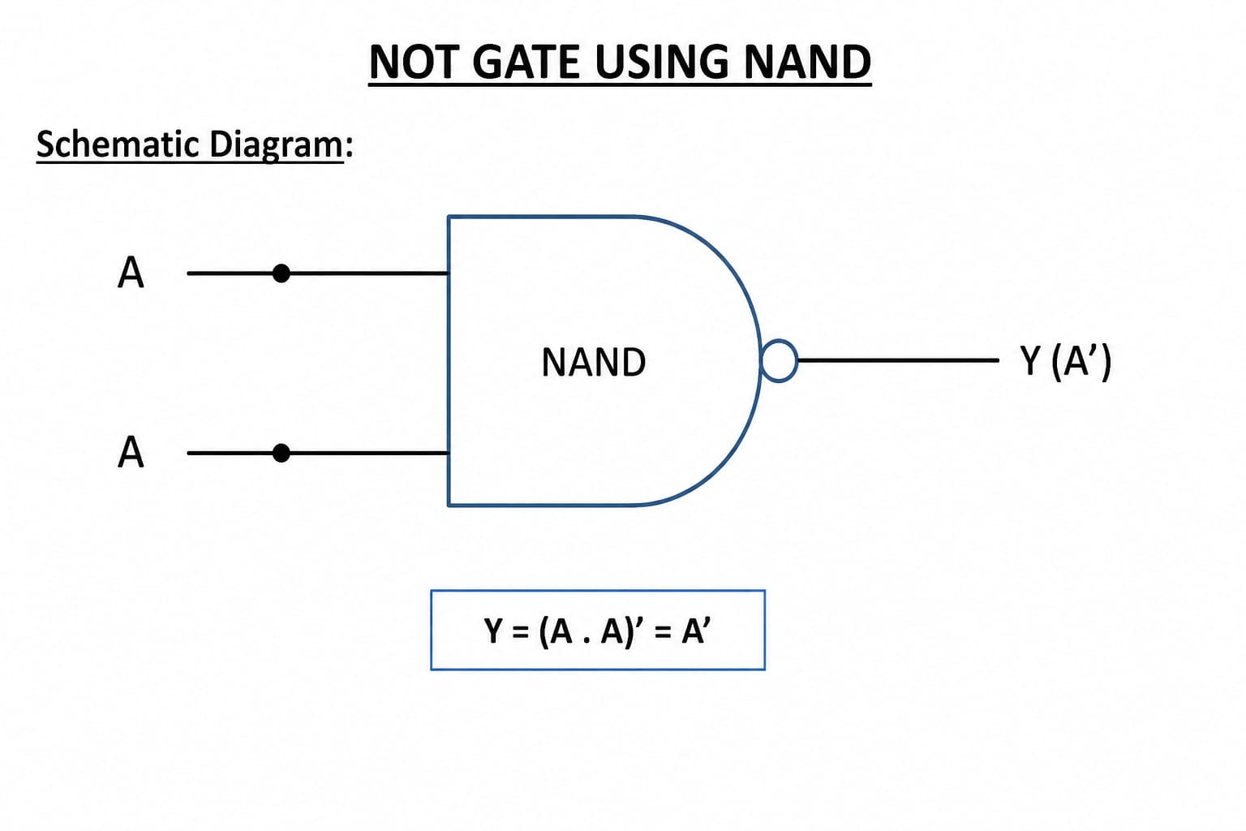
Truth Table
A | Y
0 | 1
1 | 0

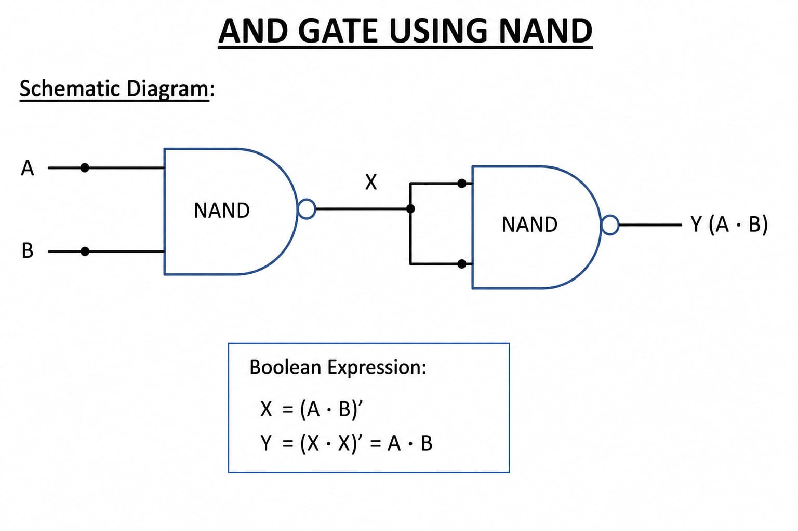

Truth Table
A | B | Y
0 | 0 | 0
0 | 1 | 0
1 | 0 | 0
1 | 1 | 1

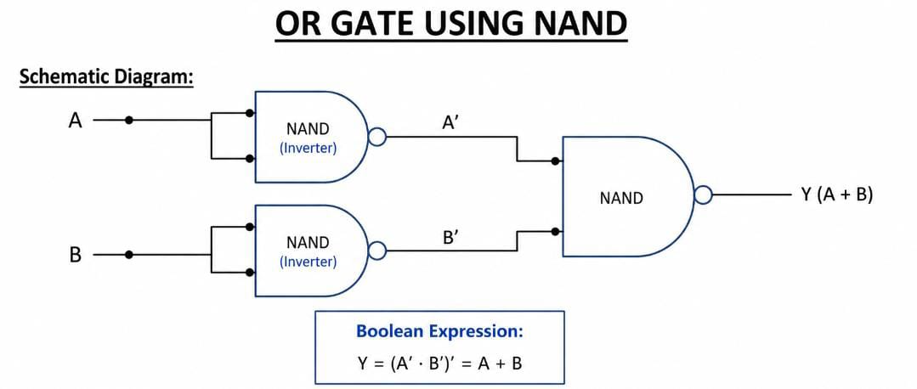

Truth Table
A | B | Y
0 | 0 | 0
0 | 1 | 1
1 | 0 | 1
1 | 1 | 1

HDL CODE
NOT
CHIP Not {
IN in;
OUT out;
PARTS:
Nand(a=in, b=in, out=out);
}

AND
CHIP And {
IN a, b;
OUT out;
PARTS:
Nand(a=a, b=b, out=nandOut);
Nand(a=nandOut, b=nandOut, out=out);
}
OR
CHIP Or {
IN a, b;
OUT out;
PARTS:
Nand(a=a, b=a, out=notA);
Nand(a=b, b=b, out=notB);
Nand(a=notA, b=notB, out=out);
}
SIMULATION OUTPUT
NOT
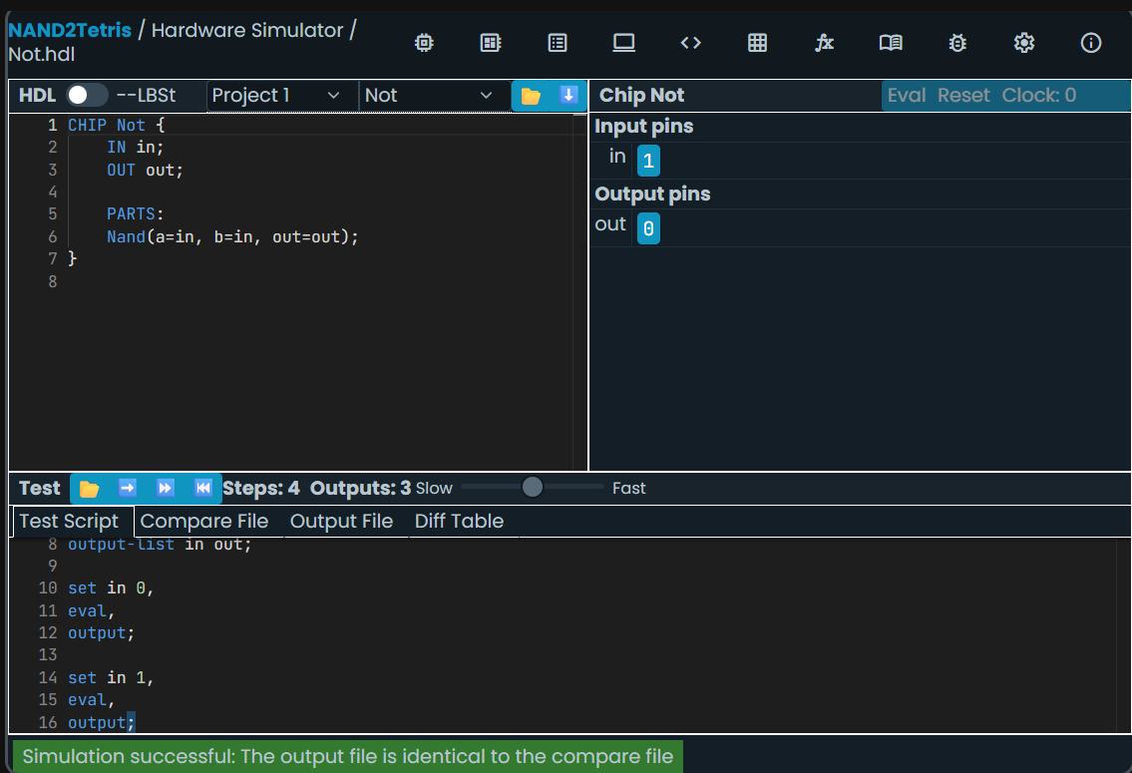

AND
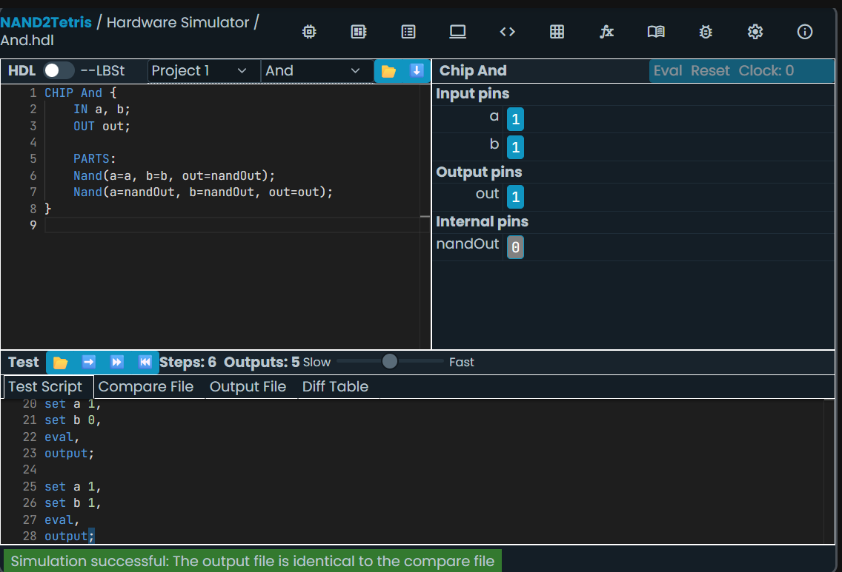
OR
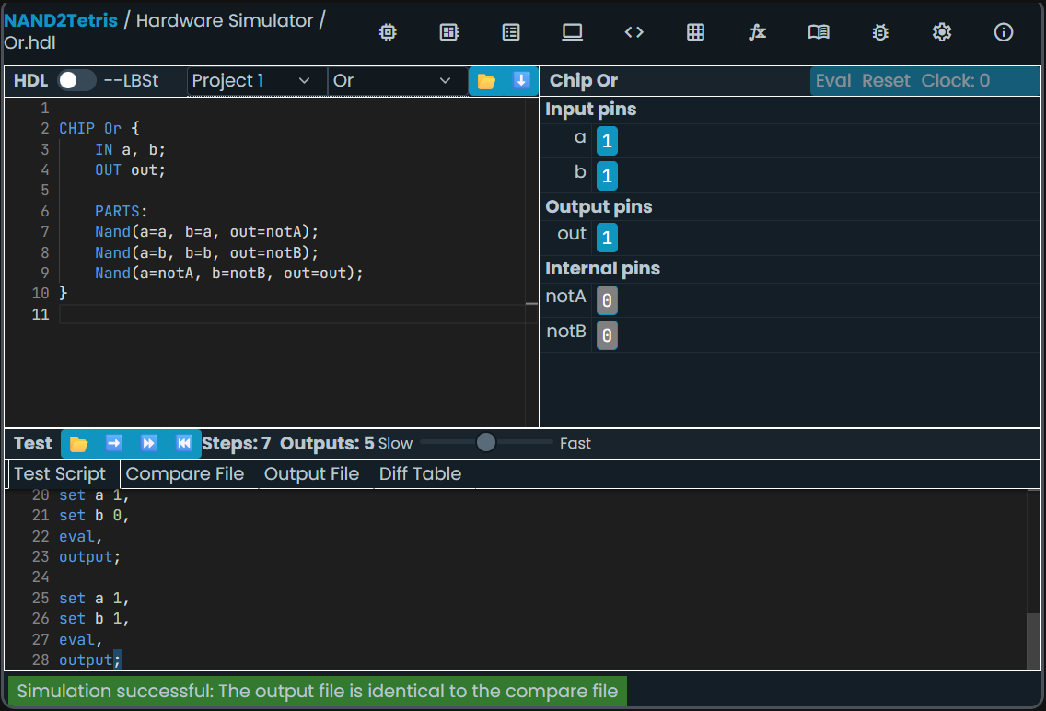
RESULT
The NOT, AND and OR gates were implemented successfully using only NAND gates. The outputs can be checked in the NAND2TETRIS Simulator and compared with the expected truth tables.

